Please take time to think through the following questions and submit quality answers. Your effort is highly appreciated and the level of detail in your answers greatly enhances your chance of getting hired.

Question 1

Without using HTML table, please use a well-known UI framework such as Twitter Bootstrap to implement a responsive HTML form that has exactly the following layout. Please overlook the style of the dropdown boxes, which depends on OS/Browser.

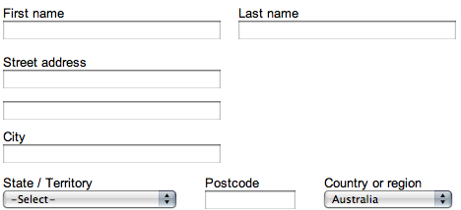

Just include the UI framework name, the form part of the HTML code, and any custom CSS in your answer.

Question 2

Please write a function in Java that parses a string, which represents IP address without delimiter, and returns all possible IP address permutations in an array.

Example 1
Input: “12345” Output: [“1.2.3.45”, “1.2.34.5”, “1.23.4.5”, “12.3.4.5”]

Example 2
Input: “123” Output: []

Question 3

Please write the unit test code to test the function in Question 2. Include as many test cases as you deem necessary.

