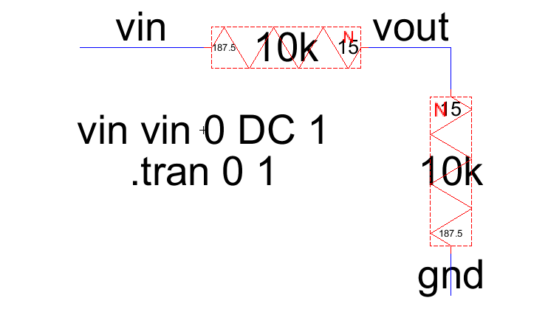
Diagram above is my diagram that has been followed by Dr. Jacob tutorial. It shown the error below before starting simulation
Error
