EMC Regulation in Taiwan and South Korea
Director Masatoshi Hirato
Global Technomanagement Institute
With the unification of the EU, there is increased demand for conformity to international standards to achieve uniformity of products for the expansion and development of distribution. Most representative of these is the EMC directive of Jan. 1, 1996, to which conformity is demanded, one of the "New Approaches" designed by the EU.
The control or management of electromagnetic wave conformity has already been in practice for quite some time in Europe, Japan and the U.S., where various markings on products have been made compulsory.
This is exemplified by the compulsory registration system of the FCC in the U.S. and the CE marking of products required in Europe.
In coordination with such requirements, EMC conformity required in New Zealand and Australia will now be required likewise in Taiwan and Korea starting Jan. 1, 1997.
Please refer to the following, where the EMC regulations in Taiwan and Korea are defined in detail.
Addition of the standards themselves would be too voluminous. You are requested to directly obtain the actual standards with respect to areas that concern you.
The application of EMC regulation in Taiwan was commented on in detail in the lecture given at the 10th anniversary of VCCI by Mr. Tang Yung-Chi of BCIQ when an explanation was given on the "Management of Electromagnetism in Commercial Products." Although those who heard the lecture on the EMC restrictions by the Australian staff as well are already aware of the facts, a simple explanation will now be given of the restrictions which have been realized.

EMC Regulation in Taiwan
1. Background
BCIQ which is the institution that manages EMC regulation in Taiwan. BCIQ has determined standards that must be followed in the design, manufacture and sales of products that are liable to cause electromagnetic interference and products that are liable to be easily affected by electromagnetic interference, to prevent such products from disrupting communications and information processes.
It is essential that products be viewed on a common basis by employing labeling for accredited products, to enable the consumer to make proper identifications at the time of purchase and also make it easier for manufacturers to sell products.
EMC regulations should also make mutual accreditation possible in international consultations on the inspection or qualification of products.
The labeling of products as conforming to electromagnetic wave requirements is now compulsory in the labeling of products.
Manufacturers are required to submit applications for products which are compulsorily regulated and are required to acquire labeling for conformity verification.
2. Range of regulations concerning electromagnetic wave conformity
The following four categories of products are subject to restrictions.
(1) Disposable, domestic and light industry manufactured products: General electrical appliances, electronic products (including semi-manufactured products), and office equipment and supplies.
(2) Equipment and devices for maintenance and installation: Devices for computer information network systems
(3) General transportation facilities equipment: Including passenger transport vehicles, freight transport vehicles
(4) Large (Heavy) Scale Industrial Products
The categories of stipulated products are a result of extensive discussions at BCIQ. Announcements concerning implementation will be made after discussions are held in BCIQ.
3. Implementation period of regulative management
Taiwanese EMC regulation became effective on Jan. 1, 1997 starting with restrictions on copying machines. Other products (product groups) will be covered in graduated steps up until July 1, 1998 by the introduction of EMC restrictions.
The ranges of compulsory management of EMC regulation apply only to emissions (EMI). Regarding immunity (EMS), BCIQ has declared that the times for regulative implementation will be determined as judged necessary after observing international trends, market conditions and industrial circumstances. The following chart indicates the proposed schedule for implementation of managed regulations for electromagnetic wave interference. The dates determined are in accordance with public announcements by BCIQ. BCIQ is expected to make specific announcements on actual dates periodically.
Schedule of implementation dates for control of electromagnetic wave interference
Scheduled implementation date | Controlled products
Jan.1, 1997 | Copiers
July 1, 1997 | Domestic appliances (including induction and electrical heating products), TVs, VTRs, facsimiles, information technology equipment (ITE)
Jan. 1, 1998 | Microwave ovens, electrical power tools, telephones, audio equipment
July 1, 1998 | Other products related to electromagnetic conformity
As indicated above, the subjects of Accreditation Registration as Electromagnetic Wave Conforming Products are products designated by BCIQ stipulation as articles requiring conformance to electromagnetic wave regulations. Models of such products must be registered as conforming.
In the case of imports, the applicant shall be a registered importer (agency). Parts that are to be manufactured domestically are to be registered at the location of the relevant manufacturer.
4. Conformance standards
The standards required to be met in conformance evaluation are related to product tests conducted internationally on similar products and are applied in accordance with international standards. They are therefore designated as international standards that have been adopted by Taiwan.
Chart of Taiwan EMC specifications
Implementation date | Applicable products | Taiwan Specifications | International Specifications
Jan.1, 1997 | Copiers | CNS 13438 | CISPR 22
July 1, 1997 | TVs, Videos | CNS 13439 | CISPR 13
July 1, 1997 | Facsimiles, Information Technology Equipment (ITE) | CNS 13438 | CISPR 22
July 1, 1997 | General domestic appliances | CNS 13306 | CISPR 14
Jan.1, 1998 | Microwave ovens | CNS 13306 | CISPR 11
Jan.1, 1998 | Electric power tools | CNS 13306 | CISPR 14
Jan.1, 1998 | Telephones | CNS 13438 | CISPR 22
Jan.1, 1998 | Audio equipment | CNS 13439 | CISPR 13
July 1, 1998 | Other products related to electromagnetic wave conformity | -- | --
Since most of the standards are based upon CISPR standards, the basic requirements are probably well understood.
However in Taiwan, the classifications of EMC restrictions are all for Class B. Class A products are confined to special items (example: supercomputers, etc.).
This is said to be a result of conditions prevailing in the home building sector, which are rather difficult to understand from the Japanese point of view, so that the reader is cautioned on this particular aspect.
5. Independent declarations
At the present time, independent declarations are not recognized. The direction may change in the future, if a proper qualifying testing institution is established.
Performance certification of Taiwanese testing institutions is compulsory. There are 7 testing institutions at present (designated testing departments for electromagnetic wave conformance) whose testing departments have been recognized by BCIQ according to the "key stipulations for management of evaluation of accreditation for electromagnetic wave conforming products."
Testing departments qualified by the BCIQ are to be periodically announced as they are qualified.
The issuing of the test performance certifications and approval registrations in relation to EMC regulations are undertaken by BCIQ. When sample testing is required, "model tests" conducted by the testing departments (currently there are only 7) licensed by BCIQ on the basis of ISO guideline 25 will become compulsory.
6. Application for registration of electromagnetic wave conformity accreditation
The applicant prepares samples for model tests and requests that model tests be conducted by the "EMC designated test department" designated by BCIQ. The applicant thereby secures a "EMC model test report."
In some cases it is possible to obtain a ruling by BCIQ, making "model tests" unnecessary. Details should be clarified with the authorities.
Subsequently, the necessary accreditation procedure is followed by submission to the respective BCIQ department (For further information, you are requested to send inquiries.). From there it is transferred to other departments after which a registration number is issued.
This is not an accreditation number, so that this number is not labeled on the product.
Documentary evaluation is undertaken. If at this stage, decision indicates a lack of proper documentation, the applicant may be requested to resubmit materials for sample testing purposes (If evaluation based on documents is difficult, part or all of items may be subject to retest.).
The applicant must submit samples as soon as possible. The EMC department (10m open site) of the BCIQ conducts accreditation.
The accredited product receives a notification of "accreditation certificate for an electromagnetic wave conforming product." The said certificate carries the accreditation number.
A product that fails to receive accreditation shall be provided with a "Rejection Notice." Accredited products are to be announced in the "Monthly Test Reports" of BCIQ.
Applications for registration require accompanying documents covering technical data similar to the documents required by the EMC directives in Europe.
* Product catalogue with color photographs (exterior and internal configuration, measuring more than 4 x 6 inches each)
* User's Manual and Operating Manuals (in Chinese)
* Block diagram of circuitry
* Circuitry diagram and explanatory material (in Chinese or English)
Of the above 4 requirements, the 2nd to 4th must also be signed by the applicant.
It must be noted that at this point the applicant must also indicate where and how the registration number (ID) will be labeled on the product.
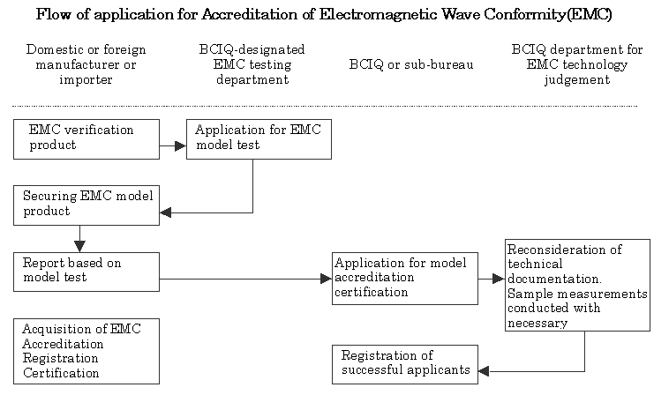
7. Labeling of model accreditation
Upon receiving product accreditation by BCIQ, the product is to be labeled with the accreditation registration number in accordance with the product procedure for "EMC model accreditation registration."
The "ID" contents are to have the following meaning in accordance with the "basic rules for EMC model accreditation registration numbers." The registration number consists of the two characters "KENJI"() and an 8-digits number (a combination of the four groups, A, B, C, and D). Labeling follows the following methods. 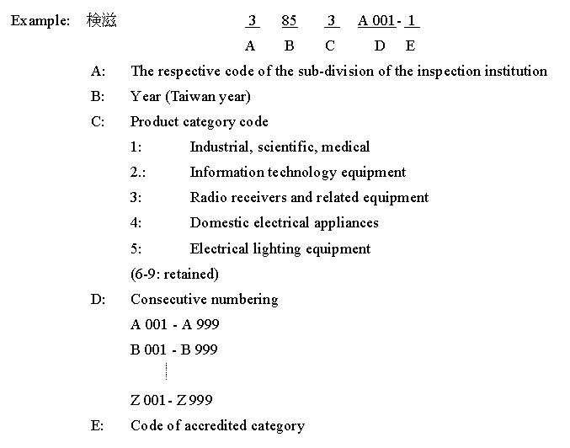
EMC regulations are already valid in Taiwan. Therefore, responses must be accompanied by a full understanding of the existing standards. The content enumerated here are not by any means complete. The necessary stipulations and applicable documentation must be studied and fully accommodated.
Information may be obtained by telephoning BCIQ at Taiwan 02-3932324. Their Internet address is http://www.moeabciq.gov.tw, but as it is in Chinese, caution should be exercised.

