***U.S. Animal Industries Pose Disease Risks to People, Report Says***

The nation uses an enormous number of animals for commercial purposes, and regulations do not adequately protect against outbreaks, experts concluded.

* Give this article

Top of Form

Bottom of Form

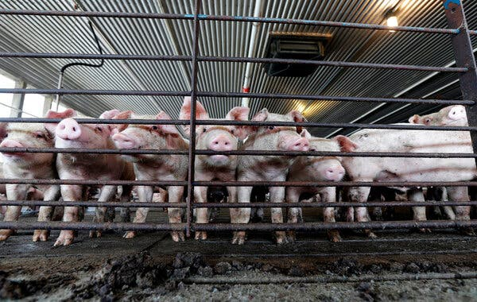

The United States produces 10 billion animals for food every year, including more pigs and poultry, which can harbor and transmit influenza, than nearly any other country.Credit...Gerry Broome/Associated Press



**By**[**Emily Anthes**](https://www.nytimes.com/by/emily-anthes)

July 6, 2023, 5:00 a.m. ET

The United States is home to an enormous array of animal industries — including industrial agriculture, fur farming and the exotic pet trade — that pose a significant risk of creating infectious disease outbreaks in humans, according to [a new report](https://animal.law.harvard.edu/wp-content/uploads/Animal-Markets-and-Zoonotic-Disease-in-the-United-States.pdf) by experts at Harvard Law School and New York University.Moreover, the nation “has no comprehensive strategy” to mitigate the dangers posed by these practices, many of which operate with little regulation and out of public view, the authors concluded.

“The risk is staggering, because our use of animals is staggering,” said Ann Linder, the report’s lead author and a research fellow at Harvard’s animal law and policy program. “And we don’t even really understand where that risk is.”

Zoonotic diseases, or those that spread from animals to humans, account for [roughly 60 percent](https://www.cdc.gov/onehealth/basics/zoonotic-diseases.html) of all known infectious diseases and 75 percent of new and emerging ones, according to the Centers for Disease Control and Prevention.

Although the exact origins of the Covid-19 pandemic remain murky, the possibility that the coronavirus might have first jumped into humans at a live animal market in Wuhan, China, prompted calls to shut down these so-called wet markets, especially in Asia.

ADVERTISEMENT

[Continue reading the main story](https://www.nytimes.com/2023/07/06/health/animals-agriculture-disease-spillover.html?searchResultPosition=1#after-story-ad-1)

“It was very unclear what people even meant by wet markets, except that they were something that exists only in other countries,” said Dale Jamieson, an author of the report and the director of the Center for Environmental and Animal Protection at N.Y.U.

But the new report highlights the extent to which Americans engage in many of these same high-risk practices. There are at least 130 live bird markets in the northeastern United States alone, the report notes; roughly 25 million birds pass through them every year.

There have already been multiple outbreaks of highly pathogenic bird flu at live bird markets in the United States this year, the report says, and evidence suggests that swine flu has previously spilled over into humans at live animal markets in Minneapolis.

The new report “should change the narrative” that spillover is a “foreign” problem, said Dr. Suresh Kuchipudi, an expert on zoonotic disease at the University of Pittsburgh School of Public Health, who was not involved in the report. “The risk of disease transmission is not really confined to a particular geography or cultural practice,” he added. “It can happen wherever there is frequent wild or domestic animal and human interactions.”

The report is part of a larger project that began in 2020, when the authors set out to assess the zoonotic disease risks posed by animal industries in 15 countries. The authors hope to publish the full global report later this year.

The authors analyzed 36 animal markets in the United States, including dog breeding, hunting and trapping, livestock auctions, backyard chicken farming and petting zoos. To assess how much risk each industry posed, they conducted interviews with experts and reviewed scientific papers, publicly available data, government regulations and more. For each industry, they considered 10 factors, including the number of animals involved, the pathogens they are known to carry and the interactions they have with humans, as well as any relevant biosecurity practices and regulations.

“We just discovered so much that was surprising to us,” Dr. Jamieson said, starting with the staggering number of animals used for commercial purposes in the United States. The country produces more than 10 billion land animals for food every year, including more pigs and poultry, which can harbor and transmit influenza, than nearly any other country, Ms. Linder said.It is also the world’s leading importer of both livestock and wild animals, the report says. (More than 220 million live wild animals are imported annually.)

The regulatory landscape, however, is “inconsistent and full of holes,” Ms. Linder said. Inspections of wildlife imports are spotty, and even when they do occur, they focus on enforcing conservation regulations rather than on disease, she said. No federal agency claims jurisdiction over mink farms, which became Covid-19 hot spots, and before the pandemic some states did not know how many of these farms were located within their borders, the authors note.

The findings highlight a need for more regulation and better public education, Dr. Kuchipudi said. Many Americans may not even realize that some of these industries and practices exist, he noted, but “the risk can then impact all of us.”

The report is just a starting point, the authors said, and key information — including basic data on the size and location of some animal industries — remains unknown. (People working in some of these industries failed to respond to the authors’ queries, Ms. Linder said.) The next step, they said, is to fill in some of these data gaps and conduct more detailed assessments of the riskiest practices.

“These threats are out there,” Ms. Linder said, “whether we turn on the lights and face them or just continue taking comfort in the dark.”

[**Emily Anthes**](https://www.nytimes.com/by/emily-anthes) is a reporter for The Times, where she focuses on science and health and covers topics like the coronavirus pandemic, vaccinations, virus testing and Covid in children. [More about Emily Anthes](https://www.nytimes.com/by/emily-anthes)