MQTT OCF Gateway Design Issues

Revision History
Date | Rev | Modified By | Description of Changes
Oct 28, 2018 | 0.1 | Khaled Elsayed | First Draft of Document. First attempt at responding to issues raised by Scott King.

Overall Architecture and Flows
The following figures explain the flows for creating and handling MQTT device subscribe and publish requests handled by the MQTT OCF Proxy. The corresponding flows for the case when a device creates an OCF resource and how that is translated into MQTT operations will be added later.
Note that the interface between the OCF_Proxy and the OCF_Client is realized using typical IoTivity procedures. All provisioning, onboarding, securing procedures associated with OCF resources can be followed. The flows below assume MQTT transaction are unsecured.

MQTT Publisher Flow
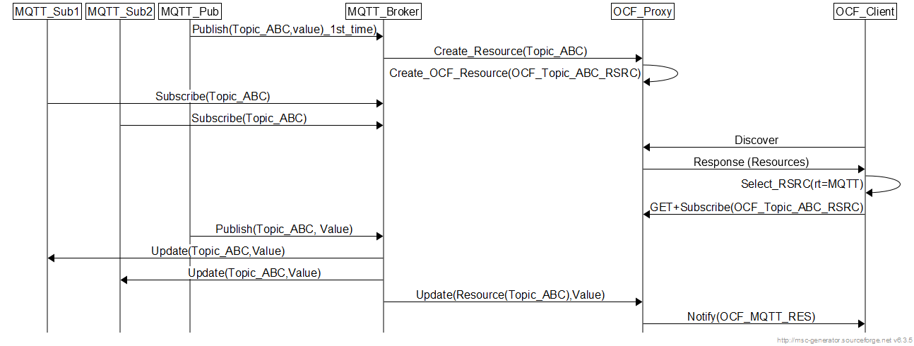
Figure 1: Flows for (non-secured) MQTT Publisher

MQTT Subscriber Flow
Figure 2: Flows for (non-secured) MQTT Subscriber

Design Issues
The following table holds some open issues to capture feedback on the design and implementation. Once code is shared via github, the issues will be handled via normal github pull requests/issues.
1 | There should probably be more specs for device onboarding and cloud-side handling of messages:
1.1 | How does the device provisioning process differ from the current cloud spec?  - Are we assuming that all local network communication still uses iotivity/coap?
Response | The created OCF resource corresponding to an MQTT topic is treated like any other OCF resource.  All local network communication between OCF clients and the resource is coap based.  MQTT publisher/subscriber connect to the MQTT broker using TCP
1.2 | How does the device determine whether it’s being setup with a coap cloud or mqtt cloud? (hopefully that could be determined from the URI)  - If there are subtle differences between how to interface with MQTT brokers from different public clouds, how do you communicate that to the device?
Response | Not clear. TBD.
1.3 | How did you want to handle bi-directional communication?  - The device not only needs to know where to publish, but also where to subscribe and how to interpret the payload
Response | Bi-directional communication between which entities. It is assumed MQTT device knows the MQTT broker.  We already have bi-directional communication. An OCF client can update the OCF resource and the updated values are pushed to the subscribers. Or an MQTT publisher sending a publish with new data, the data is pushed to an OCF subscriber to the resource created for the MQTT topic.
2 | I’m not 100% clear what work needs to be done to translate MQTT messages for a OCF client
2.1 | - How is the device supposed to publish/expose/advertise its resources/metadata such that the resource directory can correctly respond to discovery/introspection requests?
Response | Once the OCF proxy creates the MQTT topic resource with the proper properties, it is straight-forward to discover the RD and fill its database with the proper information about the resource. This can be added to the code easily (previously done with BLE proxy, so it is just a function call away).
2.2 | - How are you retaining the POST/GET semantics?
Response | Not clear. Post/GET will be done as before on the created OCF resource. The resource values are updated by with the MQTT publisher or the OCF client if the security provisions allow it. Then the values are propagated in both direction to MQTT subscribers and to clients that GET or subscribe to notifications.  What are the semantics that need to be retained? I am not a web programming guru by any sense 😊
2.3 | - Will there be any modifications to the payload? If so, does this introduce any complications? I forget if iotivity uses CWT/COSE (RFC 8392/8152)
Response | No the published values/structures/strings are moved as is to the resource. Currently, I record whatever string was published in the topic and take that as the updated resource value. Not sure if this makes sense or not. I am sure there is a better way.  Not sure about the CWT/COSE. TBD
3 | I’m interested to hear your thoughts on MQTT topic/OCF resource syntax  devices should subscribe to the topics like {userID}/{deviceID}/client/{resourceName} and publish to {userID}/{deviceID}/server/{resourceName}
3.1 | - It seems like breaking up your topics by resource is a best practice https://www.hivemq.com/blog/mqtt-essentials-part-5-mqtt-topics-best-practices
Response | Yes, I currently map the topics to the resource using very similar approach. Needs some enhancements before code is releases.  For the other direction which is if we have an OCF resource and we want to export it as a MQTT topic to potential subscribers, it is still work in progress. I am not sure if it makes sense to allow MQTT publishers to publish to the topic and update the resource like an authorized OCF client. I am not sure how to handle the security related procedures. Maybe work for following releases.
3.2 | - Not sure how you store the relevant metadata about the resource though (ex: what resource type is {resourceName}?
Response | I use a rt of oic.r.mqtt.<MqttTopic> where MqttTopic is the MQTT Topic (not standardized of course. Just some proper rt)
3.3 | - How am I supposed to know that “bathroomLight” is oic.r.switch.binary instead of oic.r.light.brightness?)
Response | I think we will need to pass some semantic information via the MQTT topic publisher. No clue if that is supported in MQTT or not.

More

