4X Gear Package  (part no. L4XGEARS)  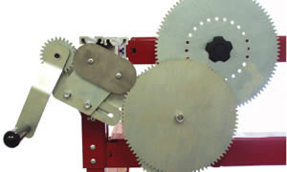  This is the Heavy Duty Gear Set developed for our model 2000 and 2200 customers that are milling architectural columns. For some of our friends and customers there is a need to create long pitch spirals. Anyone that has created a large rope design (8" to 11" in diameter) knows that even the 15" pitch can look a bit out of porportion. Longer pitches can resolve this problem, bringing a more verticle look back to your larger diameter rope projects.  Built of heavy 1/4" plate, the gears and linkage were designed to eliminate slippage or jumping. This set of gears allows pitches to be milled within the 1.5 to 120 inch range.  These longer pitches aid in reproducing gothic as well as other unusual designs.  What you should know:  - Replaces all your existing gears.  - Replaces your existing pivot arm.  - Always uses the same spindle drive gear (end of the spindle shaft).  - 4 steps of reduction means your headstock gear chart must be replaced with a new one.  - The shortest pitch currently available is 1.5"  - Will slightly reduce the maximum taper when milling spirals on the model 900.  Features:  - Spiral Drive | Specs:  Pitches included in the set:  Group1: 1.5, 1.875, 2, 2.25, 2.5, 3, 3.75, 4.5, 5, 5.625, 6, 7.5 inches per rotation  Group 2: 6, 7.5, 8, 9, 10, 12, 15, 18, 20, 22.5, 24, 30 inches per rotation  Group 3: 24, 30, 32, 36, 40, 48, 60, 72, 80 90, 96, 120 inches per rotation

