Test Configuration
- In our experiment we have used LwIP as network stack with RPL as routing protocol. We have added the neighbor cache management policy as a configurable module to the LwIP network stack.
- Whitefield simulator is used to simulate the mesh network on an Ubuntu X86_64 machine.

Test Topology
Number of nodes in the network: 64
Network topology: Grid based (8x8)
Grid Dimension: X axis- 80 meter Y axis- 80 meter
Wireless configuration: 802.15.4 in 2.4GHz range with single channel (channel 26)
Multiple access protocol: Unslotted CSMA
Physical data rate: 512KBps
Mac layer maximum retry count with exponential back off: 6
MAC layer MTU: 128 Bytes

Test Steps
Experiment has been conducted with different neighbor cache sizes 10, 20 and 40. For each NC size we have collected sample readings for packet delivery rate and network convergence time, by enabling and disabling the Neighbor Cache Management Policy (NCMP).
Data transmission policy:
Each node in the network sends 104 bytes (IPv6 Header + RPI + UDP + Data) of UDP request to BR at each 10 second interval. udp Server running at BR process these requests and sends the response back , which is also of same size 104 bytes.
We give a time of 2 minutes delay, for network to get stable, before nodes starts sending request messages at 10 sec interval.
Note- To calculate PDR we have considered the request response as one successful transaction.

Impact of Neighbor Cache Management Policy
We have analyzed two primary points, impact on the Packet Delivery Rate (PDR) and the network convergence time. PDR calculation was relatively easy but the convergence time, turned out, is not so easy to identify. We defined convergence as the point at which BR becomes aware of all the routes to the nodes in the network.

Impact on PDR
Below diagram shows the comparison study of packet delivery rate with and without neighbor cache management policy.
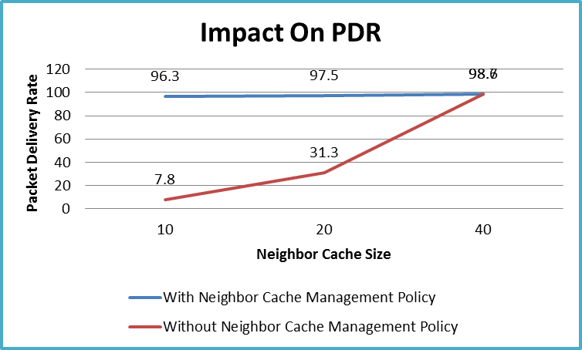
Observation-:
It’s observed that when the NBR cache size is relatively lower compare to the number of nodes in the network NCMP helps the network to become stable and perform better. Without NCMP network never stabilizes and PDR is extremely bad.
Why without NCMP bidirectional PDR is bad:
- When NC size id relatively less compare to number of nodes in the network neighbor replacement algorithm will kicks in more frequently. It will lead to removal of one neighbor entry to make space to add a new entry.
- When a neighbor entry gets removed the entire routing paths via that neighbor will become invalid. All the downward data traffic for over those routing paths will lead to the forwarding error.

Impact on convergence time

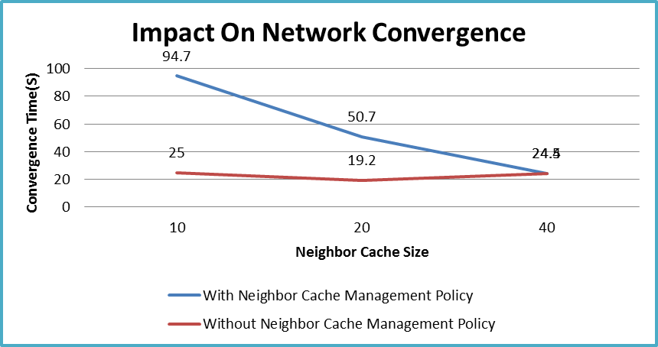
Observation-:
It’s observed that when the NBR cache size is relatively lower compare to the number of nodes in the network with NCMP network convergence time is little longer.
Why network convergence is bad with NCMP:
- With NCMP enabled, LR and BR will rejects the DAO messages from the direct children if all the slots for direct children are already full. This will force the child node to choose another parent as preferred parent.
- With NCMP LR and BR also announce about the availability of the NC slots for direct child in the DIO message. Children nodes will use this information to update their parent table and keep parents with NC space available in their probable preferred parent list.
Note: As stated before procedure to calculate convergence time, is not so easy to identify we defined convergence as the point at which BR becomes aware of all the routes to the nodes in the network. Tough the convergence time without NCMP is also better with relatively lower NC size; PDR data shows network is not really stable.

