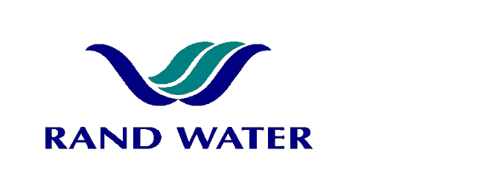

Internal and External applications are invited from suitably qualified persons to fill the following vacancy in the Operations Division at Benoni.

DISTRICT AIDE
(HAYBAND – H)

OVERALL RESPONSIBILITY
General pipeline, valve & meter repair and maintenance.

PRIMARY DUTIES
- Maintenance of pipelines, valves and meters
- Pipeline patrols by bicycle
- Standby duties
- Upkeeping of grounds
- Cleaning of buildings and offices
JOB REQUIREMENTS

Successful completion of ABET level 3

1 year experience in a similar environment
- Ability to do maintenance on pipelines
- Good communication skills
- A code 10 driver’s license or Motorcycle license would be an added advantage
- Preference will be given to applicants with disabilities

COMPETENCY PROFILE

KNOWLEDGE | SKILLS | BEHAVIOUR
- General maintenance  - Safety and safe working procedures | - Communication skills  - Ability to ride a bicycle | - Performance Driven  - High motivation  - Customer Service Orientation

In making the final selection, consideration will be given to achieving
Rand Water’s Employment Equity Objectives.

Should you not receive correspondence from Rand Water within 30 days from the closing date, please accept that your application has been unsuccessful.

Applications must be submitted to Naydine De Vries, Human Resources Department, BULK WATER DISTRIBUTION.
Fax: 0866 307 911

E-mail: recruit-bwd@randwater.co.za CLOSING DATE: 25 January 2012

