For Sale by Owner

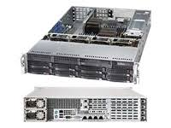
Supermicro A+ - Server 2022G-URF4+

Sale Price $2000.00

* 4 OF GIGABIT LAN PORTS
* 920W REDUNDANT POWER SUPPLY
* RAIL KIT INCLUDED
2 * CA-OPTERON-6380 AMD OPTERON 6380 SIXTEEN CORE 2.5GHZ
16MB SOCKET G34 (32-CORE PER SYSTEM)
ME-16GB-DDR31600ECCREG 16GB DDR3-1600 ECC/REG SERVER MEMORY
(128GB PER SYSTEM)
RAID-LSI-9260-8I LSI MEGARAID 9260-8I SAS2 8 PORT PCI-E X8 3

This system is like new and is less than 2years old
All systems I sell are guaranteed for 30 days after Sale.
After the 30days I will be happy to repair yours systems and a large discount of my usually hourly rate.

Contact:
David Phillips
332 Brookcourt
Springville
Cell 801-709-8069

