**Questionnaire1:**

**Please take time to think through the following questions and submit quality answers. Most answers found in Google are either wrong or out of context. Your effort is highly appreciated and answers affect your chance of getting hired.**

1. Please code a function that parses a string, which could represent IP addresses without delimiter, and returns all possible IP address permutations as an array.
2. Please List all your test cases for the function you wrote above.

|  |  |  |
| --- | --- | --- |
|  | Input | Return |
| Sample Test Case | “12345” | [“1.2.3.45”, “1.2.34.5”, “1.23.4.5”, “12.3.4.5”] |
| Test Case 1 |  |  |
| Test Case 2 |  |  |
| … |  |  |

1. Please code another function that tests if a XML string has all matching tags. See below test cases for example. Please note that just using a library to test or parse it is not an option. Write your own to test it.
2. Please List all your test cases for the function you wrote above.

|  |  |  |
| --- | --- | --- |
|  | Input | Return |
| Sample Test Case 1 | <node>    <element att1="a" att2="b"/>  </node> | True |
| Sample Test Case 2 | <?xml version="1.0"?>  <node>    <element att1="a" att2="b">  </element> | False |
| Test Case 1 |  |  |
| … |  |  |

1. How do you automate the above two set of test cases?

**Questionnaire2:**

**Please take time to think through the following questions and submit quality answers. Most answers found in Google are either wrong or out of context. Your effort is highly appreciated and answers affect your chance of getting hired.**

1. Without using HTML table, please use a well-known UI framework such as Twitter Bootstrap to implement a responsive HTML form that has exactly the following layout. Please overlook the style of the dropdown boxes, which depends on OS/Browser.

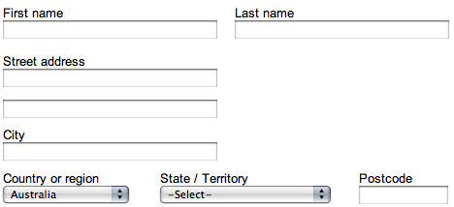

Just include the UI framework name, the form part of the HTML code, and any custom CSS in your answer.

**2)** In the above HTML form, we want to make possible values of “State / Territory” dropdown depend on the selected value of “Country or region”. For example, Australia has 8: “Australian Capital Territory”, “Northern Territory”, “New South Wales”, “Queensland”, “South Australia”, “Tasmania”, “Victoria”, and “Western Australia”, while USA has 50 states and D.C. Please write the JavaScript function to implement this.

**Questionnaire3:**

**Please take time to think through the following questions and submit quality answers. Most answers found in Google are either wrong or out of context. Your effort is highly appreciated and answers affect your chance of getting hired.**

1. Please write a function in Java that parses a string, which could represents IP addresses without delimiter, and returns all possible IP address permutations in an array.

Example 1

Input: “12345”                   Output: [“1.2.3.45”, “1.2.34.5”, “1.23.4.5”, “12.3.4.5”]

Example 2

                Input: “123”                        Output: []

1. Please write the unit test code to test the function in Question 2. Include as many test cases as you deem necessary.