
We're making a "Big Splash" in schools!!
Don't miss out on this of a deal!!
Buy a minimum of 1 Network Version or Site License and get...
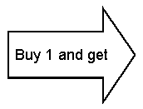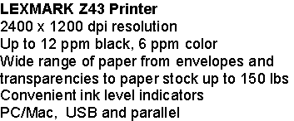
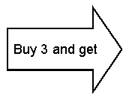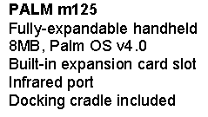
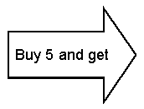
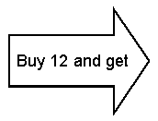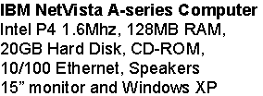

To Contact Sacheen Kerr from Riverdeep—The Learning Company call:
800-825-4420 Press 7 then 4735 or email: skerr@riverdeep.net
Don't pass this up!! Call 800-825-4420 Press 7 then 4735 for more information. Call Sacheen Kerr
**********************************************************************************
***Restrictions and Conditions Apply***
1. Promotion applies only to Network and Site Licenses
2. Promotion cannot be combined with any other promotion
3. Promotion is for benefit of End-user customer only- Bonus product drop shipped to End-user customer only
4. TLCSA purchases do not apply. TLCSA customers may choose either this promotion OR their standard 10% discount for Networks
and Site licenses
5. Level of Bonus product determined by number of licenses purchased on ONE purchase order only; Purchase orders may not be
combined to receive Bonus product
6. Customer must specify Bonus item(s) on their purchase order
7. Customer may not return any software that qualified the customer for a bonus, except for defective software. This condition supercedes
all warranties and return policies separately stated, except where prohibited by law.
8. No returns of any Bonus Product to Riverdeep - The Learning Company.
Riverdeep - The Learning Company disclaims all warranties expressed or implied on Bonus Products, except to extent prohibited by applicable
law.
End-User customer limited to Manufacturer warranty, if any
9. Equal value exchanges from Networks to Site Licenses and Site Licenses to Networks will be allowed
10. Bonus Product exchanges are not allowed at anytime
11. Promotion can be cancelled or changed at anytime
12. This promotion is only good while supplies last and expires July 31, 2002
13. Riverdeep - The Learning Company shall have no liability to End-User Customer for invoices not received by July 31, 2002 regardless of cause
14. Riverdeep - The Learning Company has the right to substitute comparable Bonus Product at anytime due to supply demand and availability of
Bonus Product
15. Offer valid in the US and Canada only. Void where prohibited, taxed or restricted.
16. Customer is responsible for all applicable federal, state, and local taxes.
17. Riverdeep-The Learning Company shall not be responsible for late, lost, misdirected, illegible, or scrambled purchase orders. Incomplete
or illegible purchase orders will not be accepted. To qualify, Purchase Order must be received by midnight July 31, 2002
18. Riverdeep-The Learning Company shall not be responsible for any injury or damage to end-user customers or any other person’s
computer equipment related to or resulting from this offer.
19. Allow 6-8 weeks for shipment of bonus product.

Don't pas this up!! Call 800-825-4420 Press 5 then 4735 for more information. Call Sacheen Kerr

To Contact Sacheen Kerr from Riverdeep—The Learning Company call:

800-825-4420 Press 7 then 4735 or email: skerr@riverdeep.net

